Project 4: Using Functions to Model Battery Power

Part 1: Estimate Time to Charge a Battery
For this project, think about an electronic device with a battery that you have to charge on a regular basis.
- What device is it?
- When you are using the device, approximately how long does it take the battery to go from $100\%$ charged until the time you need to plug it in again to recharge?
- Approximately how long does it take to charge to $100\%$ starting from $0\%$ or nearly $0\%$?
- Approximately how long does it take to charge if you plugged in your device when the battery was $50\%$ charged?
- How long do you think it would take to recharge the device to $100\%$ from $50\%$ compared to the time it would take if the device was at $0\%$? Would it be exactly half the time, more than half the time, or less than half the time it would take if starting from $0\%$?

Part 2: Analyze Percent Change Over Time
A cell phone is plugged in to be charged. The table below shows the percent of battery power at a few times after it was plugged in. Use the data to answer the following question.

Time | Percentage Charged
11:00 a.m. | $$6\%$$
11:10 a.m. | $$15\%$$
11:30 a.m. | $$35\%$$
11:40 a.m. | $$43\%$$

- At what time will the battery be $100\%$ charged? Show your reasoning.

Part 3: Write an Equation to Model Data
For questions 1-2, use the following prompt and image.
The image shows the battery usage of a cell phone 9 hours after it was fully charged. It also shows a prediction that the battery would last 8 more hours.

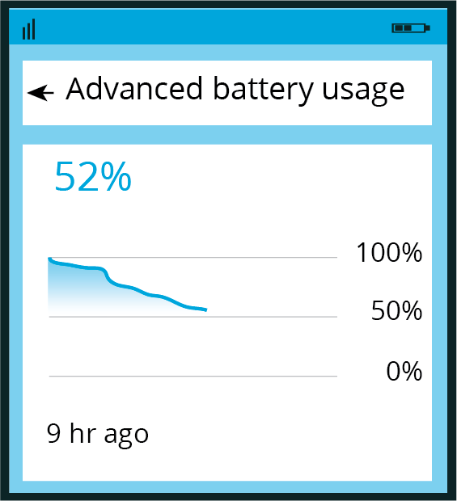
- Write an equation for a model that fits the data in the image and gives the percent of battery power as a function of time since the phone was fully charged. Be prepared to show your reasoning.
- Based on your function, what percentage of power would the battery have 4 hours after this image was taken? What about 5 hours after the image was taken? Be prepared to show your reasoning.

For questions 3-5, use the following prompt and image.
Here are two more images showing the battery usage at two later times, before the battery was charged again.

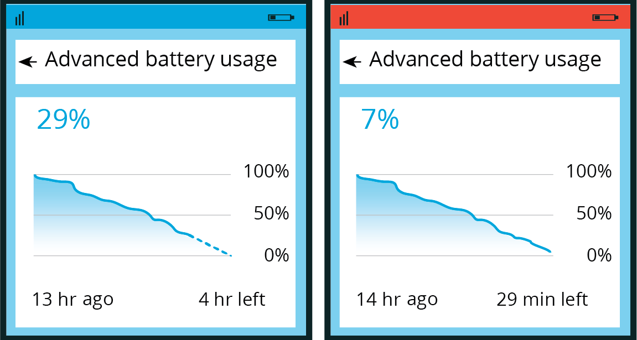
- How well did the function you wrote predict the battery power 4 and 5 hours after the first image was taken (that is, 13 and 14 hours after the battery was fully charged)? Be prepared to show your reasoning.
- What do you notice about the change in the prediction between $t=13$ and $t=14$?
- Write a new equation for a function that would better fit the data shown in the last image.

If you get stuck, consider creating a table of values or a scatter plot of the data.

